**PORTFOLIO**

**COMPUTER SCIENCE AND ENGINEERING**

Submitted by:

Name: Abhijeet Kumar

Registration number: 12406663

Section: K24CT

Roll No.: 49

**Submitted to: Dr. Joshva Raj G.**



**LOVELY PROFESSIONAL UNIVERSITY**

**DECLARATION**

I, Abhijeet Kumar, a student of Bachelor of Technology under CSE discipline at Lovely Professional University, Punjab, hereby declare that all the information furnished in this project report is based on my own work and is genuine

Abhijeet Kumar

Registrartion Number: 12406663

|  |  |  |
| --- | --- | --- |
| Platforms for profile creation | Link to student profile | Screenshot |
| ***Figma*** | https://www.figma.com/files/team/1408362969271220850/recents-and-sharing/recently-viewed?fuid=1408362967535972633 | 1 |
| ***Stack overflow*** | https://stackoverflow.com/users/26949954/abhijeet-kumar | 1 |
| ***Hacker Rank*** | https://www.hackerrank.com/profile/yabhijeet083 | 1 |
| ***Hacker Earth*** | https://www.hackerearth.com/@yabhijeet083/ | 1 |
| ***Geeks for Geeks*** | https://www.geeksforgeeks.org/user/yabhije708e/ | 1 |
| ***LinkedIn*** | https://www.linkedin.com/feed/?trk=guest_homepage-basic_google-one-tap-submit | 1 |
| ***Github*** | https://github.com/Abhijeet111111111 | 1 |

1.FIGMA

Profile:

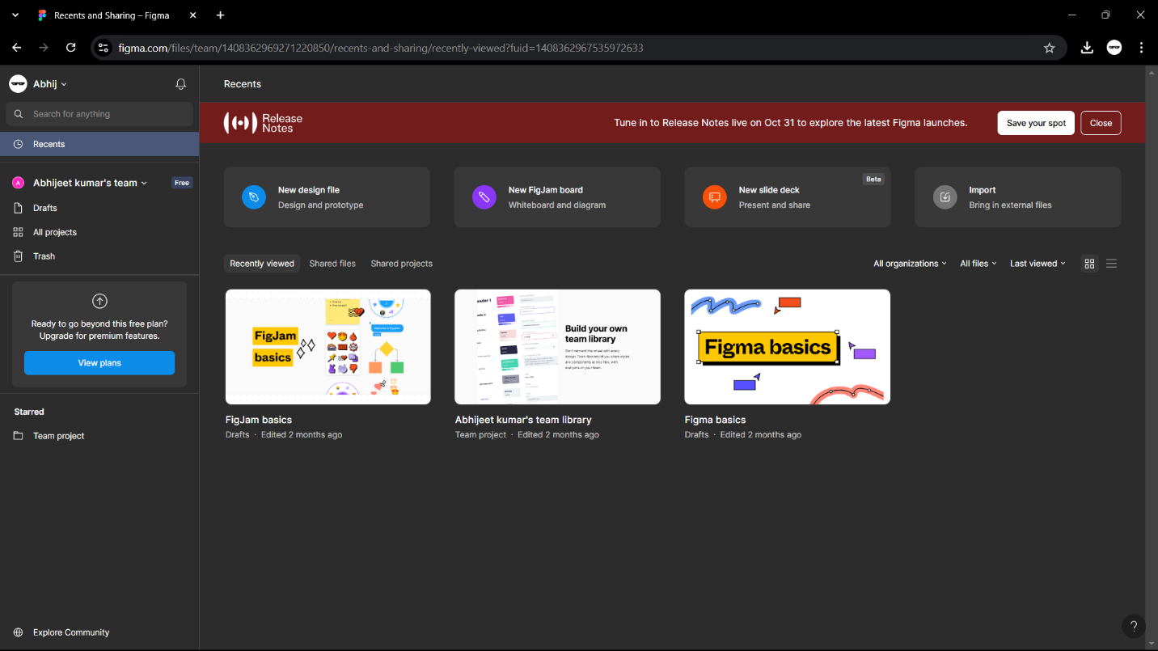

3.STACKOVERFLOW

PROFILE:

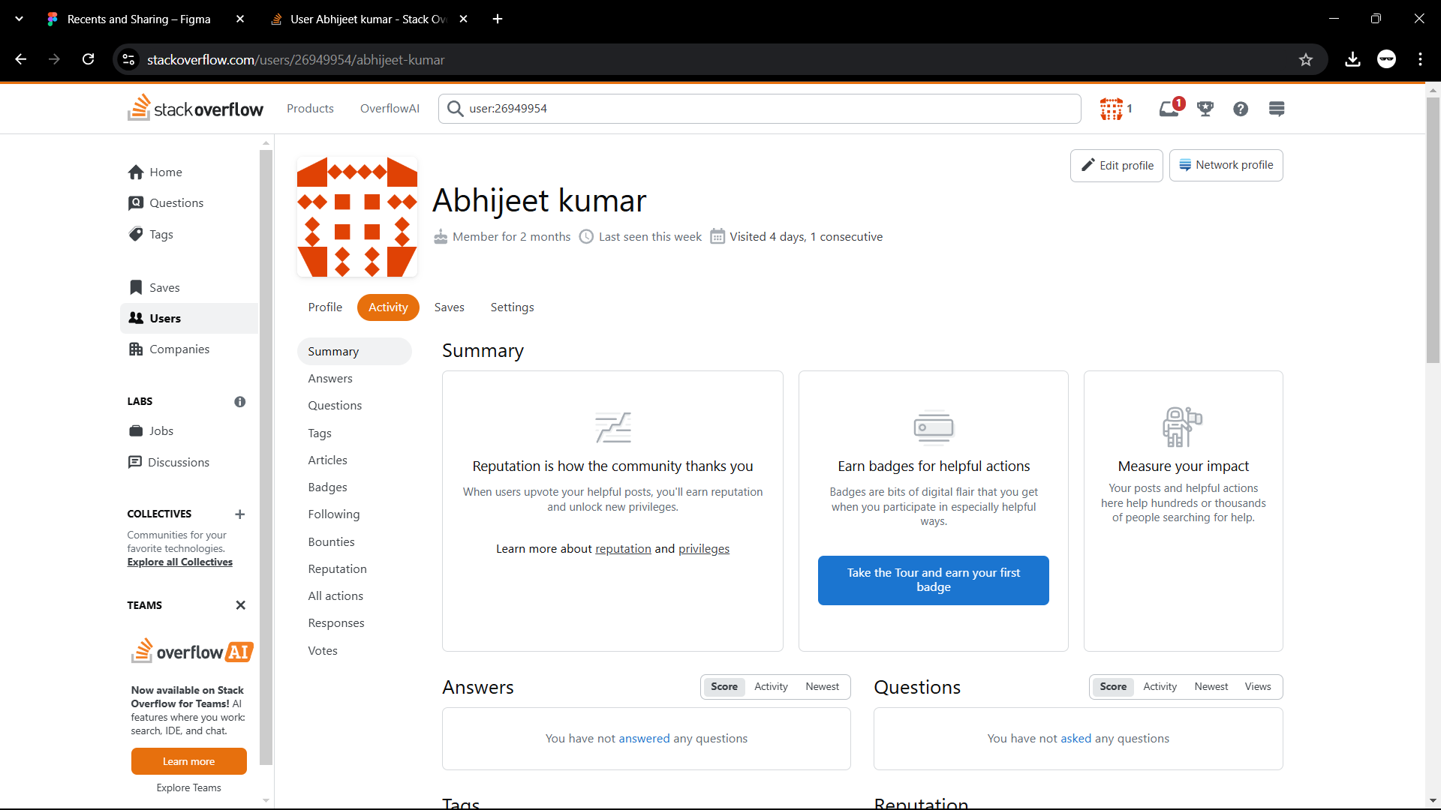

**4.HACKER RANK**

**Profile:**

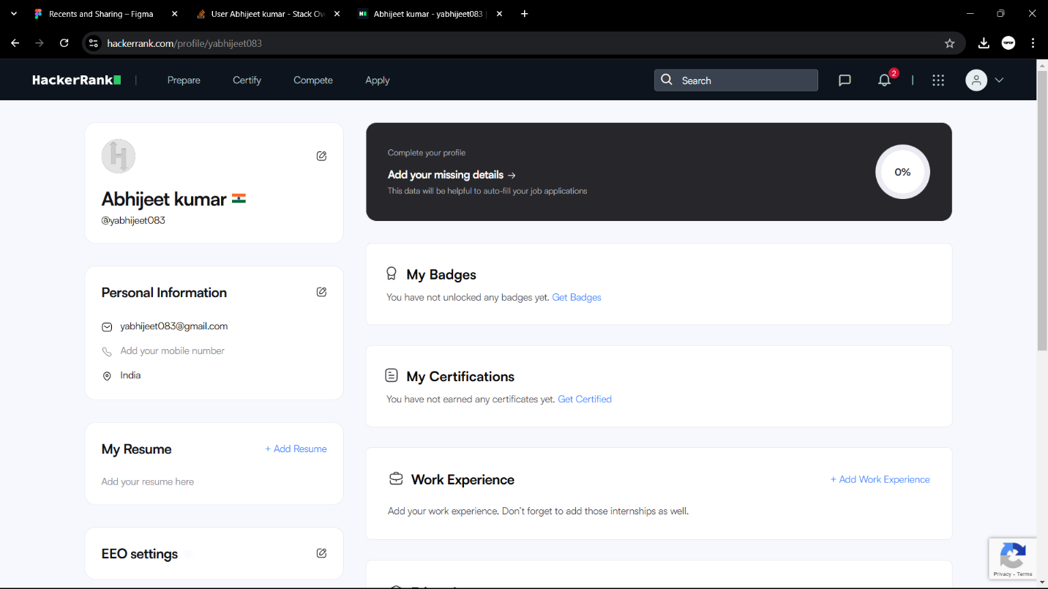

**5.HACKER EARTH**

**Profile:**

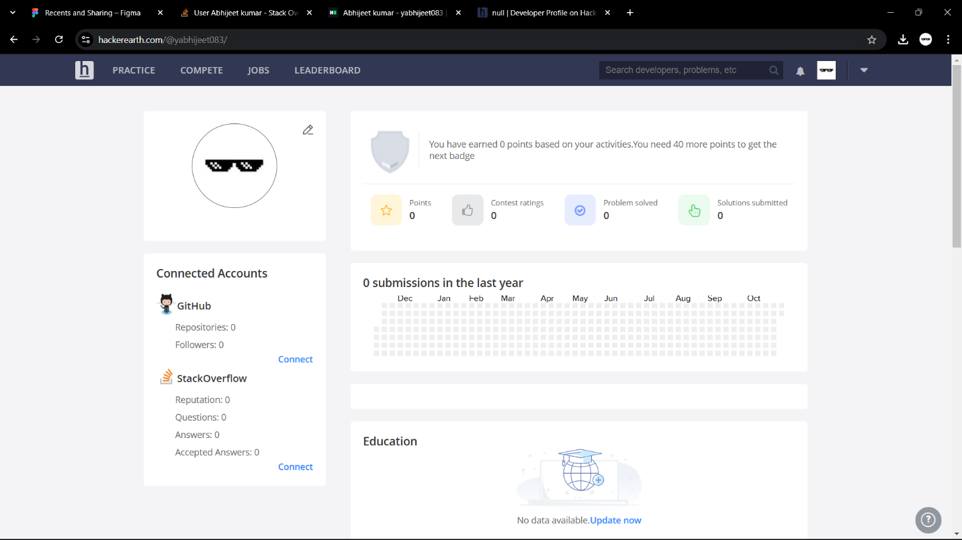

**6.GEEKS FOR GEEKS**

**Profile:**

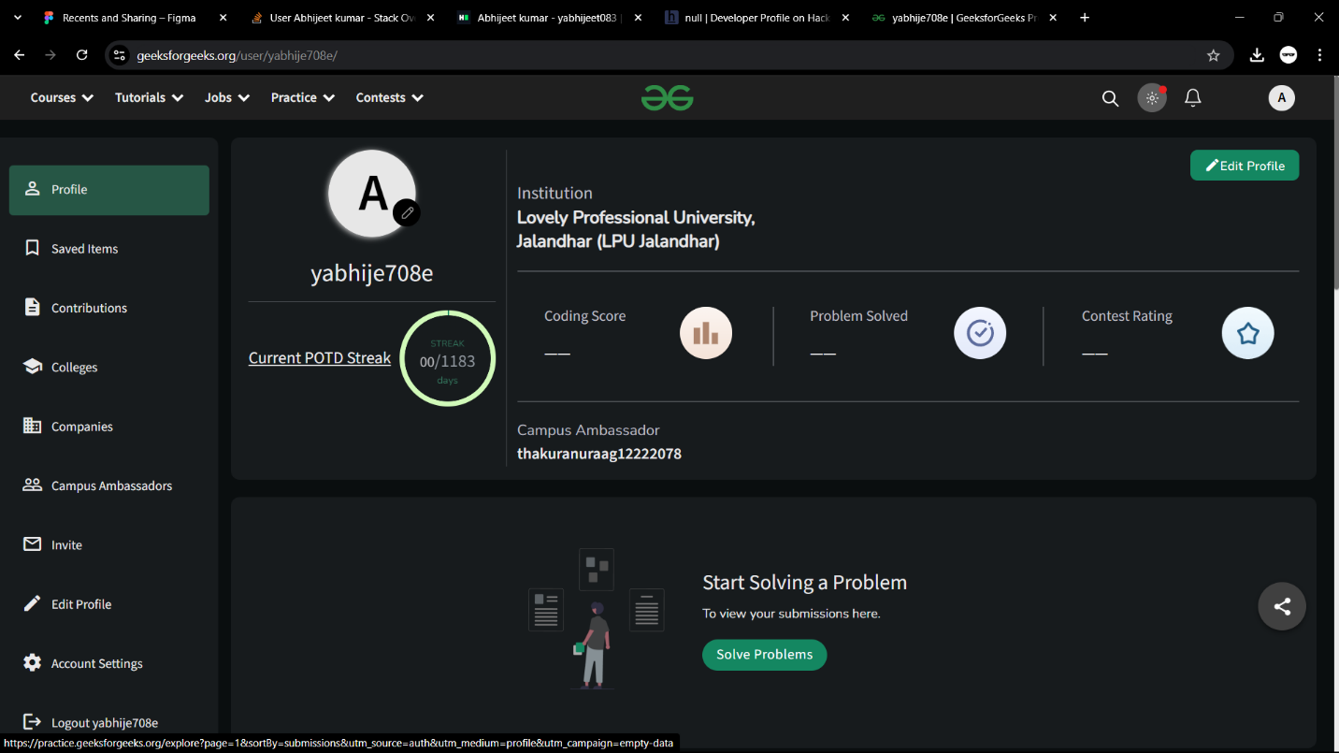

**8. GITHUB**

**Profile:**

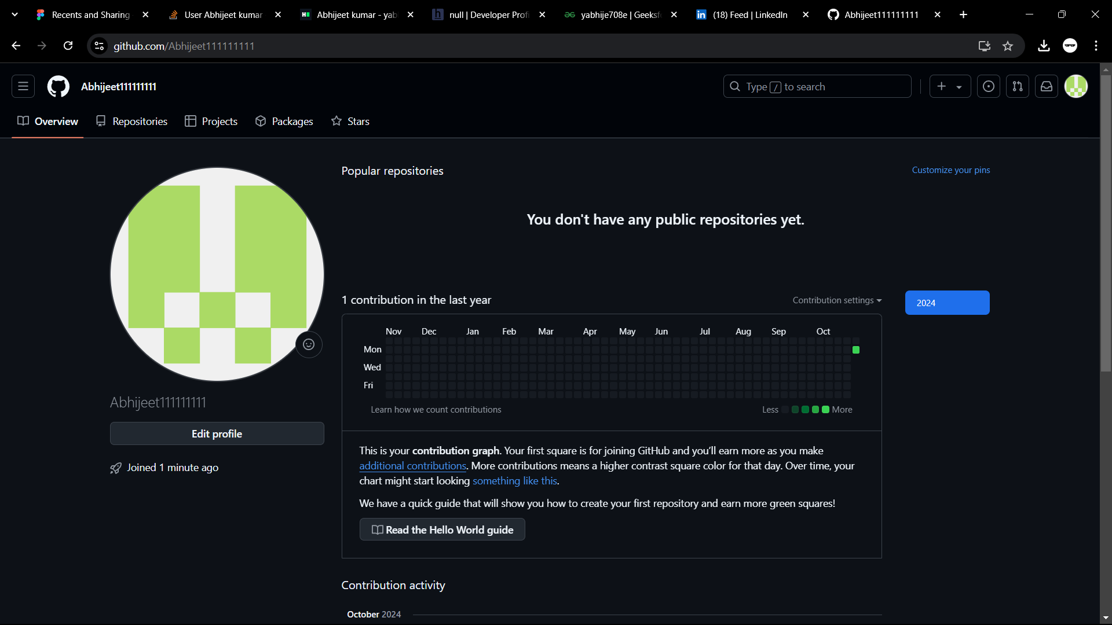

**10.LinkedIn**

**Profile:**

